Chapter 10, Solution 58.

For the circuit depicted in Fig. 10.101, find the Thevenin equivalent circuit at terminals a-b.

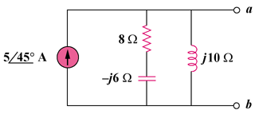

Figure 10.101
For Prob. 10.58.

Solution

Consider the circuit in Fig. (a) to find .

(a)

8

j10

-j6

Z_{eq}

= 11.1826.56

Consider the circuit in Fig. (b) to find V_{Thev}.

(b)

8

j10

-j6

545 A

I_{o}

+

V_{Thev}

= 55.971.56 V

